**ORIGIN**

An Engine can be categorized into two on the basis of combustion and they are:-

1. Internal Combustion Engine
2. External Combustion Engine

**Internal Combustion Engine**:-

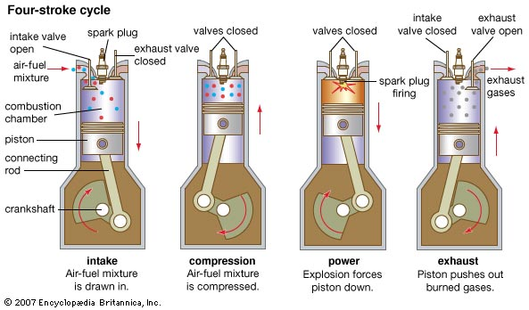 With the aid of oxygen (air), fuel and spark plug heat, the combustion is formed in the Engine Cylinder. The energy so generated pushes the piston thereby the engine gets activated. Resultantly, the carbon dioxide (CO2) is emitted as smoke. This is called Open type Engine.

Example – Petrol and Diesel Engines.

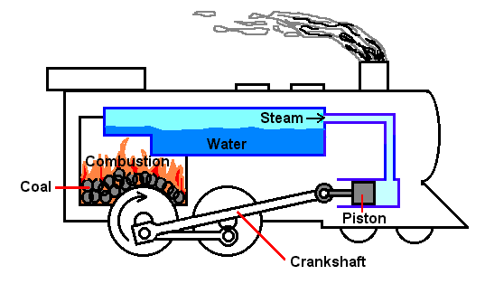

**External Combustion Engine:-**

The engine activates due to the steam generated while heating coal and water in the boiler. This is open type engine. Example – Steam engine.

**Heat Engine : -**

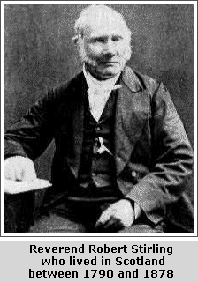At the time when Steam Engine was in vogue, Mr. Robert Stirling has invented Closed type hot air engine. In this process, the air which is present in the engine cylinder is heated and the pressure emanated thereof activates the engine. However, these types of Engines could not be used for motor vehicles due to the usage of working fluids such as H2, He, N2, air. Besides, water could not be used as working fluid in a closed type engine because of it’s Leidenfrost effect.

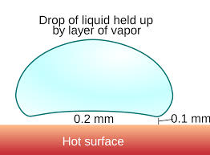 If a drop of water is spilled on a hot metal plate, the water so dropped does not get converted into steam immediately because, in between the water dropped and the hot metal plate, a steam layer having is 0.1mm thickness is formed which prevents the water from getting converted into steam immediately. This is called as Leidenfrost effect.

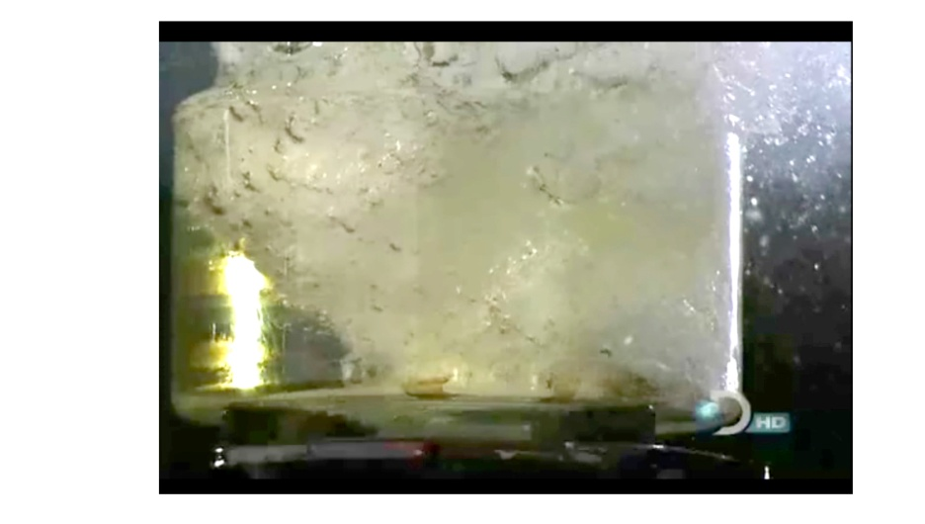On the other hand, if water is spilled on a hot oil, the water so dropped gets converted into steam immediately, because of two things. The boiling point of the water is lesser than the smoke point of the oil and the density of the water is higher than the oil. As both the hot oil and water are fluids (liquids, gases) by the heat convection current, the respective heat of the water and oil gets shared. As at this point the average temperature of oil is higher than the boiling point of water, water gets converted into steam immediately. By this swift explosion of steam, efficient closed type steam engine could be created.

**INVENTION**

**An Introduction**

This is a closed type steam engine. Water and Oil has to be poured in to the closed operating cylinder of this Engine. When it is heated, in between the boiling point of water and smoking point of oil, the oil gets converted into heat transfer fluid and the water gets converted into working fluid, which enables the engine to get activated.

**Parts and Figures**

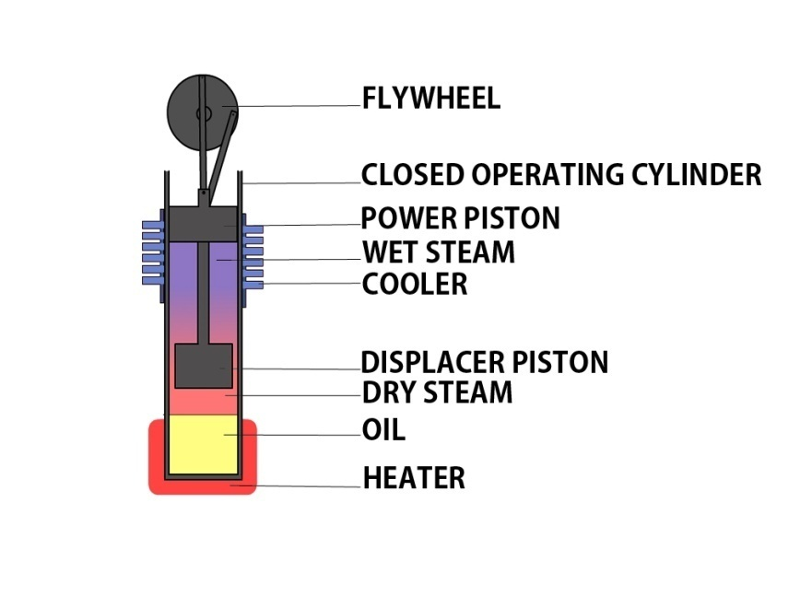

This Engine will function in four stages viz., heating, expansion, cooling and contraction

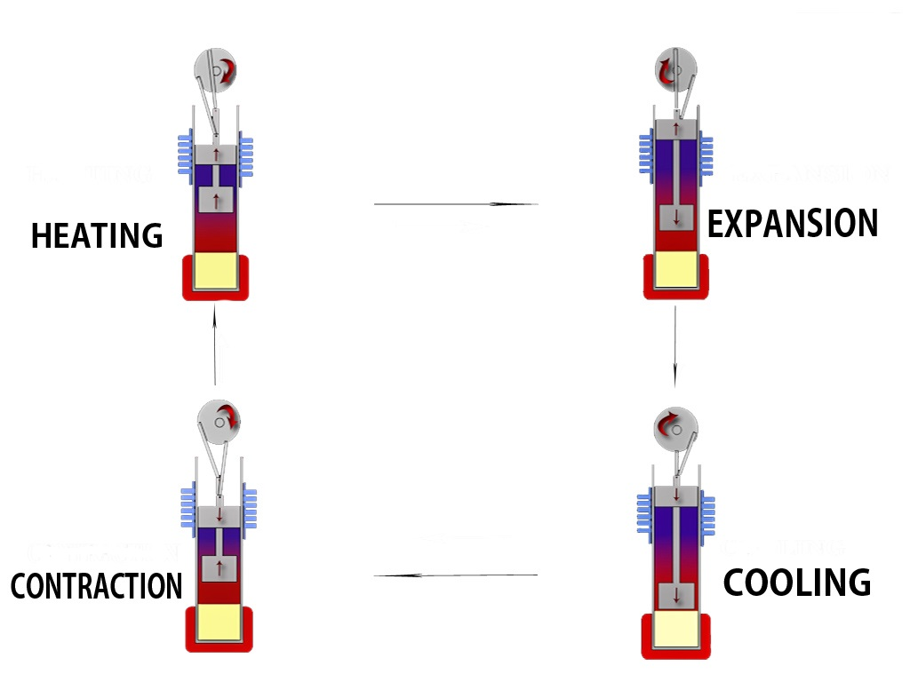

**Heating:-**

In this stage, the wet steam absorbs the heat from the surface of the hot oil and converts it into dry steam.

**Expansion:-**

In this stage, the dry steam gets expanded. The expanded dry steam pushes the power piston upwards. As the result, flywheel rotates. Simultaneously, by the movement of flywheel, the Displacer piston moves downwards and replaces the expanded dry steam into cooler.



**Cooling:-**

In this stage, Dry steam looses it’s heat in the cooler and gets itself converted into wet steam.

**Contraction:-**

In this stage, the wet steam gets contracted. As a result, the power piston moves downwards and so flywheel rotates. Simultaneously, by the movement of flywheel, the Displacer piston moves upwards and replaces the contracted wet steam on the hot oil surface.

In all these four stages, the same steam recycles itself in the closed operating cylinder and activates the engine.

**Salient features of this engine**

* This engine can be designed in such a way so that it can be used in all automobiles, air crafts, boats etc., by specifically modifying that.
* The electric energy required for functioning of this Engine will be generated by Engine itself. Therefore, there is no necessity for usage of Petrol, Diesel, LPG Gas, Coal etc.,
* Electric power can be generated with this engine by ourselves without any costs. By using this Engine, power cut will be eliminated permanently.
* There is no requirement for electricity power generation through Non-renewable sources such as Atomic power plant, Coal power plant, Natural gas power plant etc. Similarly, the renewable energy sources such as Windmill power plant, Solar power plant, Hydro power plant etc., could be dispensed with.
* The Government spends several thousands of crores for sourcing electric power generation and petroleum products and if this engine is used, it will be a thing of the past.
* This engine can be utilized for the agricultural purpose. This will result in yet another green revolution.
* This Engine will not result in any environmental pollution as this is a closed type electrical heat engine. This Engine will not emit any green house gases in any manner. Further, the environmental problems witnessed in the present day such as Ozone layer depletion, global warming, climatic change could be a thing of the past. This engine will only produce natural resources for sustainable development.
* This engine is an Eco-friendly engine

**ANALYSIS**

Example:- By using final temperature of fluids formula and steam table, to convert an open type engine having 18 hp, into a closed type steam engine, the input energy required for working fluid(steam) and heat transfer fluid(oil) will be 1 hp. After subtracting the input energy (1 hp) from the output energy (18 hp), the balance OUTPUT GAIN(17 hp) can be utilized for the functioning of the vehicle or generation of electricity. The engine can also be started with the help of inverter battery.

**CONCLUSION**

I had struggled a lot to invent this Engine. I had spent around 10 years in the process of inventing this Engine by resorting to various places and researching many procedures. In order to take this invention to it’s next level, I am seeking the support of the Government or Public Sector Undertakings or private individuals. If I get the desired support, I am certain and hopeful of utilizing the invention which I made for the welfare and development of this World within one year to secure Energy Independence.